南京理工大学紫金学院

《Java Web开发基础》实验报告



课程编号： | 03415011
课程名称： | Java Web开发基础
学 院： | 计算机学院
专 业： | 计算机科学与技术
学 号： | 2315302125
姓 名： | 崔子霖
任课教师： | 童安玲

2026年5月
实验四 JDBC访问操作数据库
实验目的
1. 熟练运用 IDEA 等开发工具编辑 Java Web 项目代码并进行调试。
2. 掌握 JDBC 访问 MySQL 数据库的基本步骤，包括加载驱动、获取连接、执行 SQL、处理结果集和释放资源。
3. 掌握对数据库表记录进行增加、删除、修改和查询的基本方法。
4. 能够将 HTML/JSP 表单、Servlet、业务服务类和 MySQL 数据库访问代码组合成完整的登录与用户管理功能。
实验内容
本次实验在 sencondTest Maven Web 项目中完成。实验环境安装并启动 MySQL 9.6.0，本地 root 用户无密码，通过 mysql 命令创建 javaweb_lab 数据库和 t_user 表。项目引入 mysql-connector-j 驱动，Servlet 通过 LoginService 调用 JDBC 代码完成登录校验、查询用户、添加用户、修改密码和根据 id 删除用户。
页面 Login.html 提供用户名和密码输入，提交到 LoginServlet。LoginServlet 获取表单参数后调用 LoginService.login 方法校验用户，成功后跳转到 Main.jsp，失败则返回错误提示。Main.jsp 展示 queryUsers 查询结果，并提供添加用户、按用户名修改密码和按 id 删除用户的入口。
1. MySQL 服务与建表语句
brew services start mysql
mysql -u root
CREATE DATABASE IF NOT EXISTS javaweb_lab
DEFAULT CHARACTER SET utf8mb4 COLLATE utf8mb4_unicode_ci;
USE javaweb_lab;
CREATE TABLE IF NOT EXISTS t_user (
id INT AUTO_INCREMENT PRIMARY KEY,
uname VARCHAR(50) NOT NULL UNIQUE,
pwd VARCHAR(50) NOT NULL
);
INSERT INTO t_user (uname, pwd) VALUES
('admin', '123456'), ('zhangsan', '123'), ('lisi', '888888');
2. MySQL 驱动依赖
<dependency>
<groupId>com.mysql</groupId>
<artifactId>mysql-connector-j</artifactId>
<version>8.4.0</version>
</dependency>
3. User.java
package org.example.jdbc;
public class User {
private int id;
private String uname;
private String pwd;
public User() {
}
public User(int id, String uname, String pwd) {
this.id = id;
this.uname = uname;
this.pwd = pwd;
}
public User(String uname, String pwd) {
this.uname = uname;
this.pwd = pwd;
}
public int getId() {
return id;
}
public void setId(int id) {
this.id = id;
}
public String getUname() {
return uname;
}
public void setUname(String uname) {
this.uname = uname;
}
public String getPwd() {
return pwd;
}
public void setPwd(String pwd) {
this.pwd = pwd;
}
}
4. DbUtil.java
package org.example.jdbc;
import java.sql.Connection;
import java.sql.DriverManager;
import java.sql.SQLException;
import java.sql.Statement;
public class DbUtil {
private static final String MYSQL_DRIVER = "com.mysql.cj.jdbc.Driver";
private static final String MYSQL_URL = "jdbc:mysql://localhost:3306/javaweb_lab"
+ "?useSSL=false&serverTimezone=Asia/Shanghai&characterEncoding=UTF-8";
private static volatile boolean initialized = false;
private DbUtil() {
}
public static Connection getConnection() throws SQLException {
try {
Class.forName(MYSQL_DRIVER);
} catch (ClassNotFoundException ex) {
throw new SQLException("MySQL driver not found", ex);
}
return DriverManager.getConnection(getMysqlUrl(), getMysqlUser(), getMysqlPassword());
}
public static void initDatabase() {
if (initialized) {
return;
}
synchronized (DbUtil.class) {
if (initialized) {
return;
}
try (Connection conn = getConnection(); Statement stmt = conn.createStatement()) {
stmt.executeUpdate("CREATE TABLE IF NOT EXISTS t_user ("
+ "id INT AUTO_INCREMENT PRIMARY KEY,"
+ "uname VARCHAR(50) NOT NULL UNIQUE,"
+ "pwd VARCHAR(50) NOT NULL)");
stmt.executeUpdate("INSERT INTO t_user (uname, pwd) "
+ "SELECT 'admin', '123456' WHERE NOT EXISTS "
+ "(SELECT 1 FROM t_user WHERE uname='admin')");
stmt.executeUpdate("INSERT INTO t_user (uname, pwd) "
+ "SELECT 'zhangsan', '123' WHERE NOT EXISTS "
+ "(SELECT 1 FROM t_user WHERE uname='zhangsan')");
stmt.executeUpdate("INSERT INTO t_user (uname, pwd) "
+ "SELECT 'lisi', '888888' WHERE NOT EXISTS "
+ "(SELECT 1 FROM t_user WHERE uname='lisi')");
initialized = true;
} catch (SQLException ex) {
throw new IllegalStateException("初始化数据库失败", ex);
}
}
}
public static String getDatabaseName() {
return "MySQL";
}
private static String getMysqlUrl() {
String value = System.getProperty("jdbc.url");
if (value == null || value.trim().isEmpty()) {
value = System.getenv("JDBC_URL");
}
return value == null || value.trim().isEmpty() ? MYSQL_URL : value;
}
private static String getMysqlUser() {
String value = System.getProperty("jdbc.user");
if (value == null || value.trim().isEmpty()) {
value = System.getenv("JDBC_USER");
}
return value == null || value.trim().isEmpty() ? "root" : value;
}
private static String getMysqlPassword() {
String value = System.getProperty("jdbc.password");
if (value == null) {
value = System.getenv("JDBC_PASSWORD");
}
return value == null ? "" : value;
}
}
5. LoginService.java
package org.example.jdbc;
import java.sql.Connection;
import java.sql.PreparedStatement;
import java.sql.ResultSet;
import java.sql.SQLException;
import java.util.ArrayList;
import java.util.List;
public class LoginService {
public User login(String uname, String pwd) {
DbUtil.initDatabase();
String sql = "SELECT id, uname, pwd FROM t_user WHERE uname=? AND pwd=?";
try (Connection conn = DbUtil.getConnection();
PreparedStatement ps = conn.prepareStatement(sql)) {
ps.setString(1, uname);
ps.setString(2, pwd);
try (ResultSet rs = ps.executeQuery()) {
if (rs.next()) {
return new User(rs.getInt("id"), rs.getString("uname"), rs.getString("pwd"));
}
}
} catch (SQLException ex) {
throw new IllegalStateException("登录校验失败", ex);
}
return null;
}
public List<User> queryUsers() {
DbUtil.initDatabase();
List<User> users = new ArrayList<User>();
String sql = "SELECT id, uname, pwd FROM t_user ORDER BY id";
try (Connection conn = DbUtil.getConnection();
PreparedStatement ps = conn.prepareStatement(sql);
ResultSet rs = ps.executeQuery()) {
while (rs.next()) {
users.add(new User(rs.getInt("id"), rs.getString("uname"), rs.getString("pwd")));
}
} catch (SQLException ex) {
throw new IllegalStateException("查询用户失败", ex);
}
return users;
}
public boolean delUserById(int id) {
DbUtil.initDatabase();
String sql = "DELETE FROM t_user WHERE id=?";
try (Connection conn = DbUtil.getConnection();
PreparedStatement ps = conn.prepareStatement(sql)) {
ps.setInt(1, id);
return ps.executeUpdate() > 0;
} catch (SQLException ex) {
throw new IllegalStateException("删除用户失败", ex);
}
}
public boolean updatePwdByUname(String uname, String pwd) {
DbUtil.initDatabase();
String sql = "UPDATE t_user SET pwd=? WHERE uname=?";
try (Connection conn = DbUtil.getConnection();
PreparedStatement ps = conn.prepareStatement(sql)) {
ps.setString(1, pwd);
ps.setString(2, uname);
return ps.executeUpdate() > 0;
} catch (SQLException ex) {
throw new IllegalStateException("修改密码失败", ex);
}
}
public boolean addUser(User user) {
DbUtil.initDatabase();
String sql = "INSERT INTO t_user (uname, pwd) VALUES (?, ?)";
try (Connection conn = DbUtil.getConnection();
PreparedStatement ps = conn.prepareStatement(sql)) {
ps.setString(1, user.getUname());
ps.setString(2, user.getPwd());
return ps.executeUpdate() > 0;
} catch (SQLException ex) {
throw new IllegalStateException("添加用户失败", ex);
}
}
}
6. LoginServlet.java
package org.example.servlet.jdbc;
import java.io.IOException;
import javax.servlet.ServletException;
import javax.servlet.annotation.WebServlet;
import javax.servlet.http.HttpServlet;
import javax.servlet.http.HttpServletRequest;
import javax.servlet.http.HttpServletResponse;
import org.example.jdbc.LoginService;
import org.example.jdbc.User;
@WebServlet(urlPatterns = {"/jdbc/login"})
public class LoginServlet extends HttpServlet {
private final LoginService loginService = new LoginService();
@Override
protected void doPost(HttpServletRequest request, HttpServletResponse response)
throws ServletException, IOException {
request.setCharacterEncoding("UTF-8");
String uname = request.getParameter("uname");
String pwd = request.getParameter("pwd");
User user = loginService.login(uname, pwd);
if (user != null) {
request.getSession().setAttribute("loginUser", user);
response.sendRedirect(request.getContextPath() + "/jdbc/Main.jsp");
return;
}
request.setAttribute("error", "用户名或密码失败，请重新输入。");
request.getRequestDispatcher("/jdbc/Login.jsp").forward(request, response);
}
@Override
protected void doGet(HttpServletRequest request, HttpServletResponse response)
throws ServletException, IOException {
response.sendRedirect(request.getContextPath() + "/jdbc/Login.html");
}
}
7. UserServlet.java
package org.example.servlet.jdbc;
import java.io.IOException;
import javax.servlet.ServletException;
import javax.servlet.annotation.WebServlet;
import javax.servlet.http.HttpServlet;
import javax.servlet.http.HttpServletRequest;
import javax.servlet.http.HttpServletResponse;
import org.example.jdbc.LoginService;
import org.example.jdbc.User;
@WebServlet(urlPatterns = {"/jdbc/user"})
public class UserServlet extends HttpServlet {
private final LoginService loginService = new LoginService();
@Override
protected void doPost(HttpServletRequest request, HttpServletResponse response)
throws ServletException, IOException {
request.setCharacterEncoding("UTF-8");
String action = request.getParameter("action");
if ("add".equals(action)) {
loginService.addUser(new User(request.getParameter("uname"), request.getParameter("pwd")));
} else if ("update".equals(action)) {
loginService.updatePwdByUname(request.getParameter("uname"), request.getParameter("pwd"));
}
response.sendRedirect(request.getContextPath() + "/jdbc/Main.jsp");
}
@Override
protected void doGet(HttpServletRequest request, HttpServletResponse response)
throws ServletException, IOException {
String action = request.getParameter("action");
if ("delete".equals(action)) {
loginService.delUserById(Integer.parseInt(request.getParameter("id")));
}
response.sendRedirect(request.getContextPath() + "/jdbc/Main.jsp");
}
}
8. Login.html
<!DOCTYPE html>
<html>
<head>
<meta charset="UTF-8">
<title>JDBC 登录</title>
</head>
<body>
<h2>JDBC 用户登录</h2>
<form action="../jdbc/login" method="post">
用户名：<input type="text" name="uname" value="admin"><br><br>
密码：<input type="password" name="pwd" value="123456"><br><br>
<input type="submit" value="登录">
<input type="reset" value="重置">
</form>
</body>
</html>
9. Main.jsp
<%@ page import="java.util.List" %>
<%@ page import="org.example.jdbc.DbUtil" %>
<%@ page import="org.example.jdbc.LoginService" %>
<%@ page import="org.example.jdbc.User" %>
<%@ page contentType="text/html; charset=UTF-8" language="java" %>
<%
User loginUser = (User) session.getAttribute("loginUser");
if (loginUser == null) {
response.sendRedirect(request.getContextPath() + "/jdbc/Login.html");
return;
}
LoginService loginService = new LoginService();
List<User> users = loginService.queryUsers();
%>
<!DOCTYPE html>
<html>
<head>
<meta charset="UTF-8">
<title>用户管理主界面</title>
</head>
<body>
<h2>用户管理主界面</h2>
<p>当前登录用户：<%= loginUser.getUname() %></p>
<p>当前数据库：<%= DbUtil.getDatabaseName() %></p>
<h3>用户列表</h3>
<table border="1" cellpadding="8" cellspacing="0">
<tr>
<th>ID</th>
<th>用户名</th>
<th>密码</th>
<th>操作</th>
</tr>
<%
for (User user : users) {
%>
<tr>
<td><%= user.getId() %></td>
<td><%= user.getUname() %></td>
<td><%= user.getPwd() %></td>
<td>
<a href="<%= request.getContextPath() %>/jdbc/user?action=delete&id=<%= user.getId() %>">删除</a>
</td>
</tr>
<%
}
%>
</table>
<h3>添加员工信息</h3>
<form action="<%= request.getContextPath() %>/jdbc/user" method="post">
<input type="hidden" name="action" value="add">
用户名：<input type="text" name="uname">
密码：<input type="text" name="pwd">
<input type="submit" value="添加">
</form>
<h3>根据用户名修改密码</h3>
<form action="<%= request.getContextPath() %>/jdbc/user" method="post">
<input type="hidden" name="action" value="update">
用户名：<input type="text" name="uname">
新密码：<input type="text" name="pwd">
<input type="submit" value="修改密码">
</form>
</body>
</html>
运行结果
1. 登录页面

浏览器访问 /jdbc/Login.html，输入测试用户 admin/123456。
2. 登录成功并查询 MySQL 用户列表
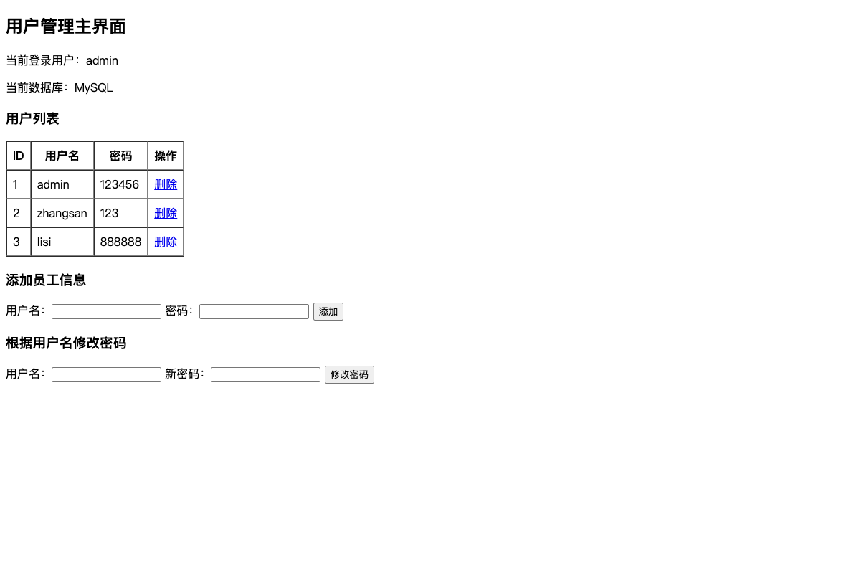
登录成功后跳转 Main.jsp，页面显示当前数据库为 MySQL，并查询 t_user 表中的三条初始记录。
3. 添加用户 wangwu
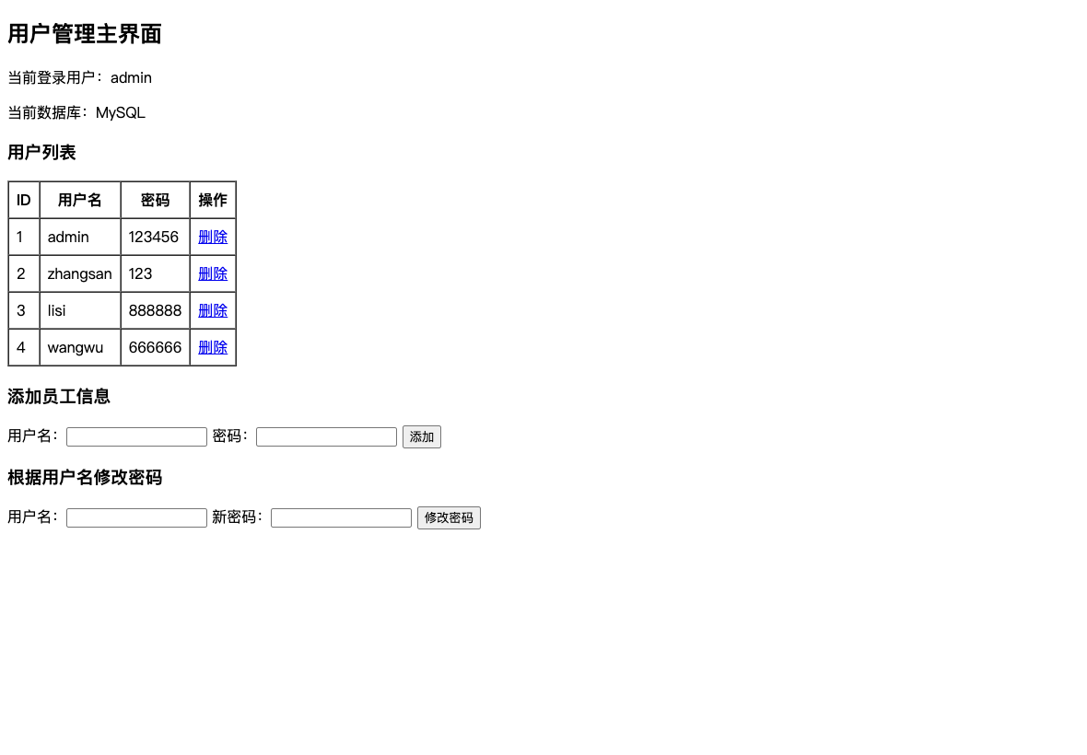
通过添加员工信息表单插入 wangwu/666666，用户列表刷新后出现新增记录。
4. 修改 wangwu 密码
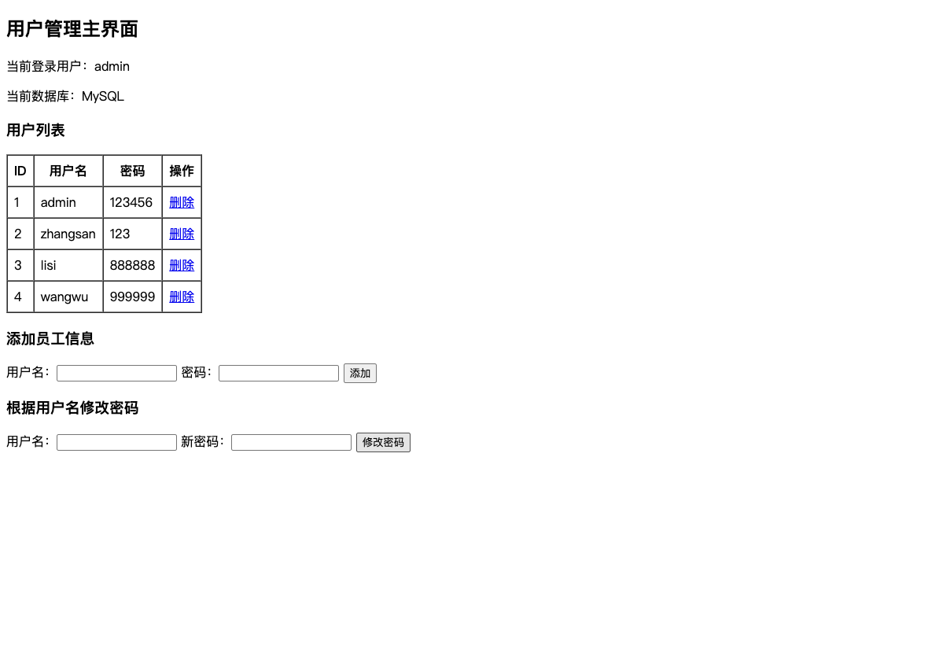
通过用户名 wangwu 修改密码为 999999，刷新列表后可以看到密码字段已更新。
5. 根据 id 删除用户

点击 wangwu 所在行的删除链接后，UserServlet 调用 delUserById 删除记录，MySQL 表恢复为初始测试数据。
实验总结
通过本次实验，完成了 MySQL 服务安装、数据库和数据表创建、JDBC 驱动引入，以及从页面表单到 Servlet、业务服务类和数据库访问层的完整流程。实验中使用 PreparedStatement 传入查询和更新参数，避免直接拼接 SQL，同时让登录校验、查询、添加、删除和修改密码的逻辑更加清晰。
调试过程中重点检查了 MySQL 服务状态、root 用户连接、JDBC URL、请求编码和页面跳转。最终项目能够成功打包并部署到 Tomcat，页面明确显示当前数据库为 MySQL，用户增删改查操作也能同步反映到 javaweb_lab.t_user 表中。

